12.64: Combining Equations (12.13) and (3.28) and setting

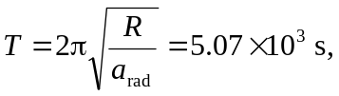

which is 84.5 min, or about an hour and a half.

